# Project : Appointment

* Functionalities
  + **On Page load** application queries database and fetches all appointments to display in table.

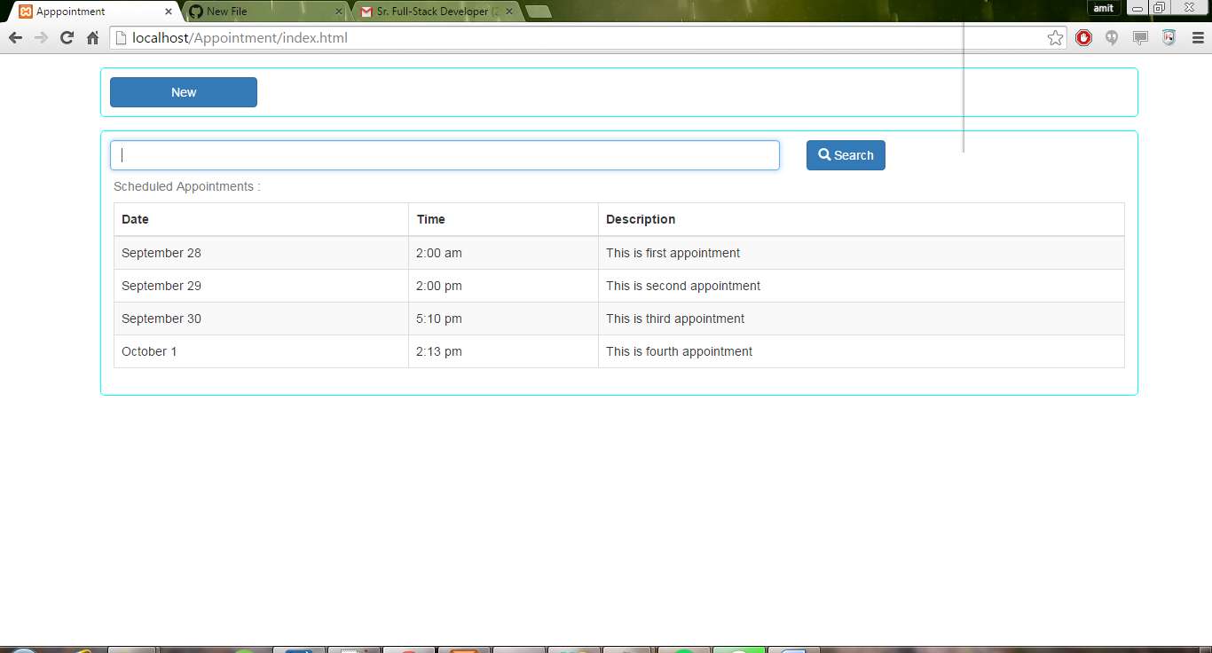

* + **On New button click** new appointment form pops up with cancel button and changes itself to **ADD button.**

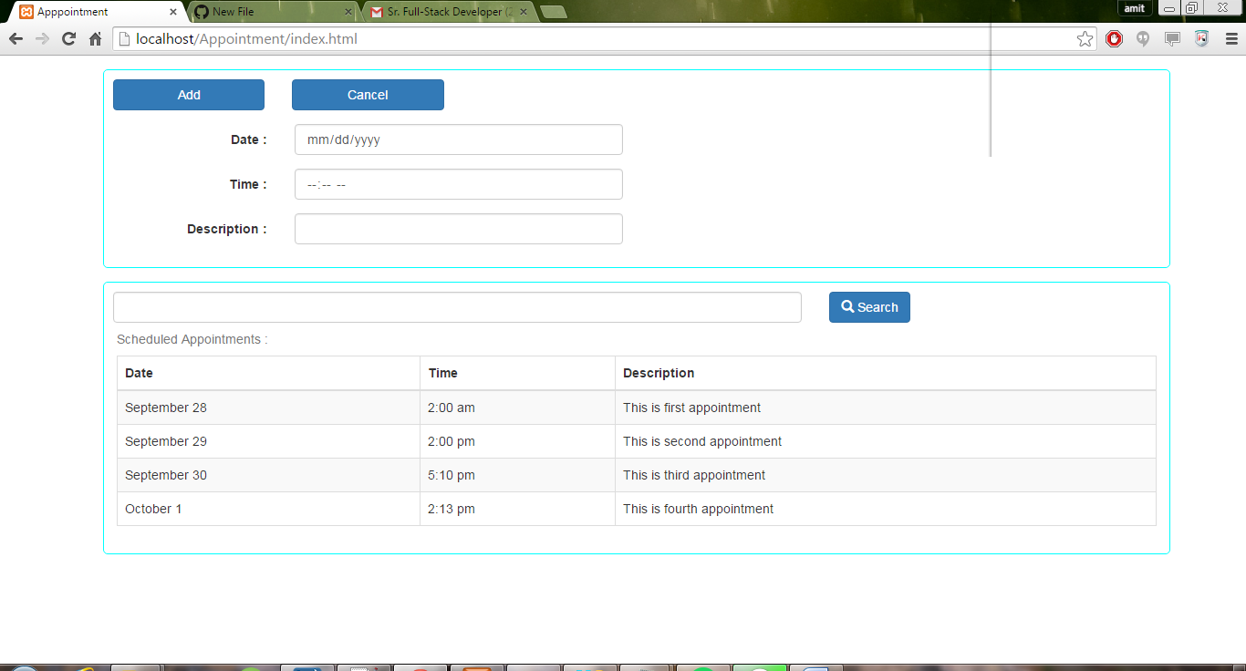

* + **On Add button click** appointment details are sent to server to feed into database and appointment table gets updated with new appointment entry.
* 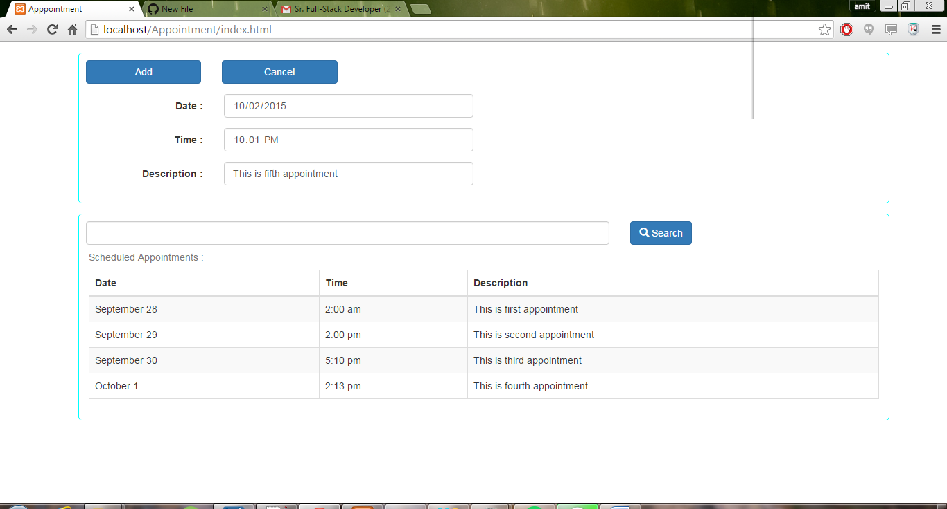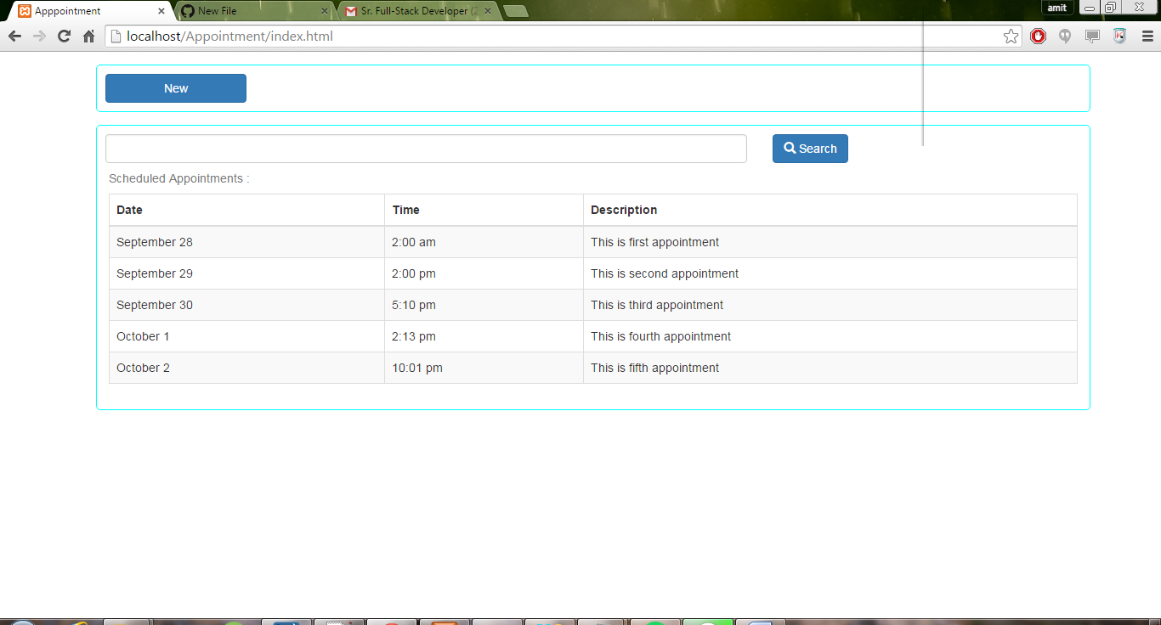
  + **On Cancel button click** appointment form hides itself and **Add button** changes to **New button**



* + **On Search button click** table populates appointment that contains description that matches searched word.

